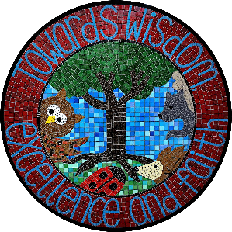
All Saints’ Anglican/Methodist Primary School, Elston
Head Teacher – Mr David Smith

“Towards wisdom, excellence and faith”

Dear Parents,

In Early Years we really value strong parent partnership. We know that you know your child best and through a strong partnership we can give your child the best opportunities. I would like to work closely with you to help with your child’s journey through Nursery and Reception and would really like your help in creating ‘All about Me’ chatterboxes that your child can share with me in September. I think this will be a great way for your child to introduce themselves and for us all to get to know each other from day one.

A chatterbox is a box, a shoe box is adequate, which contains surprise items. They are put together to encourage children to talk positively about themselves. Children often want to talk about things that they have already had experiences of and know about therefore it is important to link the contents to children’s interests and previous experiences or successes. As this is an ‘All about me’ box the contents should be important to your child and preferably chosen by them. Items could include photos, medals, a favourite toy, whatever is special to them.

I would love it if these could be brought into school during the first week for us to share during the first few weeks.

If you have any questions or queries about chatterboxes, please do not hesitate to contact me at school. I am very much looking forward to getting to know you all and working with your children.

Yours sincerely

Miss Walker

